

Oracle 20B Test Completion Report

Swiss Re Life Capital

Prepared by: Rachel Blake 27th May 2020

@Copyright 2019 Version 1 – All Rights Reserved

Table of Contents

1. Introduction 1

1.1 Purpose 1

2. Scope 1

2.1 Test Scenarios 2

2.1.1 Scenario Scope (Regression and Targeted Tests) 2

3.Test Overview 5

3.1 Tests not executed 5

3.2 Tools and processes 6

3.3 Environment set up and testing approach 6

3.4 Test execution entry criteria 6

3.5 Test execution exit criteria 7

3.6 Evidence of Regression Test Completion 7

4 Defects 8

4.1 Failed tests 8

4.2 Defect Status Summary 8

5.Communications 9

6.Lessons Learned 10

6.1 Issues and Recommended Actions 10

**Version Control**

|  |  |  |  |
| --- | --- | --- | --- |
| Date | Version | Changed By | Reason for Change |
| 27/05/2020 | 0.1 | Rachel Blake | First draft for review |
|  |  |  |  |
|  |  |  |  |

**Circulation List**

|  |  |
| --- | --- |
| Name | Organisation/Title |
| Gill Fouwels | Head of Finance IT, Life Capital |
| Chris Hunt | Solution Architect, Life Capital Finance IT |
| Gurdeep Bamrah | Technical Finance Lead, Life Capital Finance IT |
| Marios Kyriakides | Oracle Cloud Manger, Life Capital Finance IT |
| Nathan Morgan | Customer Success Manager, Version 1 |
| Raj Boparai | Head of ERP Managed Service, Version 1 |

**Reference Documents**

|  |  |  |
| --- | --- | --- |
| Title | Description | Owner |
| Oracle Cloud 20B Impact Assessment – Swiss Re Life Capital | Impact assessment of Oracle Cloud Release 20B identifying new functionality, changes and fixes that impact Life Capital’s solution. | Rachel Blake |
| Oracle Cloud 20B Test Plan – Swiss Re Life Capital | Details scope, resources and approach to testing of Oracle 20B release. | Rachel Blake |

# Introduction

This document details the results of the 20B Quarterly Update Testing. As per Oracle’s timetable for quarterly releases for wave 1, the upgrade took place on non-production environments on the first Friday of the month (01/05/20), and into the production environment on the third Friday of the month (15/05/20). This provided a 9 working day period instead of the usual 10 days for all testing to be completed, defects identified and fixes/workarounds to be in place due to the bank holiday on 08/05/20.

## Purpose

The purpose of this document is to provide details of the testing performed during the 20B Quarterly Update testing window, defects introduced by the updates, resolution details and any lessons learned.

The document provides;

* Scope of the testing
* The processes and tools used during testing
* Test execution Summary
* Defect Summary (at test completion)
* Details of any active defects (at test completion) and action plans to resolve
* Lessons learned

# 2. Scope

The scope of functional regression testing was approved by Swiss Re Life Capital key stakeholders. The golden thread suite of tests, based on key business processes was used, with the addition of further tests identified from the impact assessment of changes, new functionality and fixes documented by Oracle. As agreed - only mandatory changes were taken with the release. Non-mandatory changes will be reviewed and collated into a roadmap.

The testing suite consisted of 87 Finance tests detailed in the test plan and included below for ease of reference.

## Test Scenarios

### 2.1.1 Scenario Scope (Regression and Targeted Tests)

|  |  |  |
| --- | --- | --- |
| **ID** | **Title** | **Module / Area** |
| 241391 | INT001.10 - Run the FX Rates Interface | Inbound Interfaces |
| 241392 | INT001.20 - Validate FX Rates Emails | Inbound Interfaces |
| 241393 | INT001.30 - Validate Daily Rates Created | Inbound Interfaces |
| 241394 | INT001.40 - Validate Cross-Rates Created | Inbound Interfaces |
| 241395 | INT002.10 - Run the Employee Maintenance component | Inbound Interfaces |
| 241396 | INT002.15 - Run the Signing Authority Maintenance component | Inbound Interfaces |
| 241397 | INT002.30 - Validate New Person records | Inbound Interfaces |
| 241398 | INT002.40 - Validate Changes to Existing Person records | Inbound Interfaces |
| 241399 | INT002.50 - Validate Terminated Person records | Inbound Interfaces |
| 241400 | VEN.10 - Enter a New Supplier | Suppliers |
| 241401 | VEN.20 - Amend an Existing Supplier | Inbound Interfaces |
| 241402 | VEN.50 - Create New Bank Account for New Supplier | Inbound Interfaces |
| 241403 | INT006.10 - Run SRAM | Inbound Interfaces |
| 241404 | INT006.20 - SRAM File Archiving | Inbound Interfaces |
| 241405 | INT006.30 - Validate the SRAM Batches created | Inbound Interfaces |
| 241406 | INT006.40 - Post SRAM Journal | Inbound Interfaces |
| 241407 | INT006.50 - Validate SRAM journal replication | Inbound Interfaces |
| 241408 | INT006.60 - Run SRAM Tieback | Inbound Interfaces |
| 241409 | PO.10 - Raise a Requisition for new supplier | Purchasing |
| 241410 | PO.15 - Raise a Requisition with Multiple Lines | Purchasing |
| 241411 | PO.20 - Approve Requisition | Purchasing |
| 241412 | PO.30 - Changing a Requisition - Change Order | Purchasing |
| 241413 | PO.35 - Approve a Change Order | Purchasing |
| 241414 | PO.49 - Receipt Migrated PO | Purchasing |
| 241415 | PO.80 - Correct a Receipt | Purchasing |
| 241416 | EXP.01 - Setup UK bank account details (payment method) | Expenses |
| 241417 | EXP.10 - Enter and Submit an Expense Claim | Expenses |
| 241418 | EXP.15 - Enter and Submit an Expense Claim as a Delegate | Expenses |
| 241419 | EXP.29 - Attachment Policy | Expenses |
| 241420 | EXP.30 - Approve Expense Report | Expenses |
| 241421 | EXP.60 - Audit UK Expense - Complete Audit | Expenses |
| 241422 | EXP.70 - Transfer UK expenses to AP | Expenses |
| 241423 | EXP.80 - Payment of UK Expenses | Expenses |
| 241424 | EXP.81 - Expenses Remittance notification | Expenses |
| 241425 | AP.010 - Enter Invoice Received through Manual Payment Tool for Existing Supplier | Accounts Payable |
| 241426 | AP.015 - Enter Invoice Received through Manual Payment Tool for New Supplier | Accounts Payable |
| 241427 | AP.020 - Enter Invoice and Match to PO | Accounts Payable |
| 241428 | AP.030 - Invoice Approvals | Accounts Payable |
| 241429 | AP.035 - Approve Invoice Approval Request from WF notification | Accounts Payable |
| 241430 | PO.69 - Attempt to Over-Receipt | Purchasing |
| 241431 | PO.70 - Enter a Full Receipt | Purchasing |
| 241432 | AP.070 - Process Payment Process Request | Accounts Payable |
| 241433 | AP.090 - Verify AP Accounting Entries | Accounts Payable |
| 241434 | GL.001 - Create Manual Journal - Primary Ledger in Functional Currency | General Ledger |
| 241435 | GL.002 - Create Spreadsheet Journal - Primary Ledger - Foreign Currency | General Ledger |
| 241436 | GL.010 - Approve Journal Approval Request from WF notification | General Ledger |
| 241437 | GL.015 - Journal Posting | General Ledger |
| 241438 | GL.016 - Journal Replication | General Ledger |
| 241439 | GL.021 - Verify cannot post unapproved | General Ledger |
| 241440 | GL.022 - Verify cannot approve own journal | General Ledger |
| 241441 | GL.023 - Confirm cannot post unbalanced journal (entered currency) | General Ledger |
| 241442 | CM.010 - Load Bank Statement | Cash Management |
| 241443 | CM.011 - AutoReconciliation for Bank Statement | Cash Management |
| 241444 | CM.020 - View Imported Bank Statement | Cash Management |
| 241445 | CM.040 - Create External Cash Transactions | Cash Management |
| 241446 | INT003.10 - Enter Journal for REVEAL | Outbound Interfaces |
| 241447 | INT003.20 - Enter AP Invoice for REVEAL | Outbound Interfaces |
| 241448 | INT003.25 - Amend AP Invoice for REVEAL | Outbound Interfaces |
| 241449 | INT003.30 - Run REVEAL | Outbound Interfaces |
| 241450 | INT003.33 - REVEAL Control File | Outbound Interfaces |
| 241451 | INT003.35 - REVEAL Transaction File | Outbound Interfaces |
| 241452 | INT003.50 - REVEAL - Validate journal details | Outbound Interfaces |
| 241453 | INT003.60 - REVEAL - Validate invoice record details | Outbound Interfaces |
| 241454 | INT008.10 - Run the GFD Hierarchy Pull process | Outbound Interfaces |
| 241455 | INT008.20 - Run the GFD Movements Pull process | Outbound Interfaces |
| 241456 | REP_101 - SRLC Trial Balance - Entered and Ledger Currency | Custom Reports |
| 241457 | REP_102 - SRLC Live GL Trial Balance | Custom Reports |
| 241458 | REP_103 - SRLC Employee Spend Report | Custom Reports |
| 241459 | REP_104 - SRLC Open PO and Requisition Listing | Custom Reports |
| 241460 | REP_105 - Financial Tax Register | Custom Reports |
| 241461 | REP_109 - Income Statement | Custom Reports |
| 241462 | REP_110 - Balance Sheet | Custom Reports |
| 241463 | REP_111 - SRLC Journal Transactions Report | Custom Reports |
| 241464 | REP_116 - SRLC Negative Journal Lines | Custom Reports |
| 241465 | REP_117 - SRLC Unpaid Invoices | Custom Reports |
| 241466 | REP_120 - SRLC My Open PO and Requisition Listing | Custom Reports |
| 241467 | REP_121 - Payables Invoice History | Custom Reports |
| 241471 | EXP.35 - Approve Expense Report by Email | Expenses |
| 242886 | PO.21 - Approve Requisition by Email | Purchasing |
| 245354 | 20B.10 - Troubleshoot Requistion Approval issues using Diagnostic Report | Targeted Testing |
| 245355 | 20B.20 - Opt In - Add New Approved Requisitions to Existing Open Purchase Orders | Targeted Testing |
| 245645 | 20B.30 - Maintain Account Hierarchy Levels for Budgetary Control Reporting Using File-Based Data Import | Targeted Testing |
| 245646 | 20B.40 - Specify URL Attachments When Creating Supplier Invoices Using a Spreadsheet | Targeted Testing |
| 245834 | 20B.50 - Retain Receipt Method and Payment Instrument on Complete Transactions | Targeted Testing |
| 246187 | 20B.60 - Highlight Configuration Elements That Aren't Optimized | Targeted Testing |
| 246527 | 20B.70 Cancel Purchase Order | Targeted Testing |
| 246568 | 20B.80 Prepare Payables to General Ledger Reconciliation process | Targeted Testing |

# 3.Test Overview

This section provides summary details of the tests that were performed in each module/area, defects identified and what was and wasn’t met in relation to planned entry and exit criteria. All tests were executed with the exception of 2 identified as not applicable (see below).

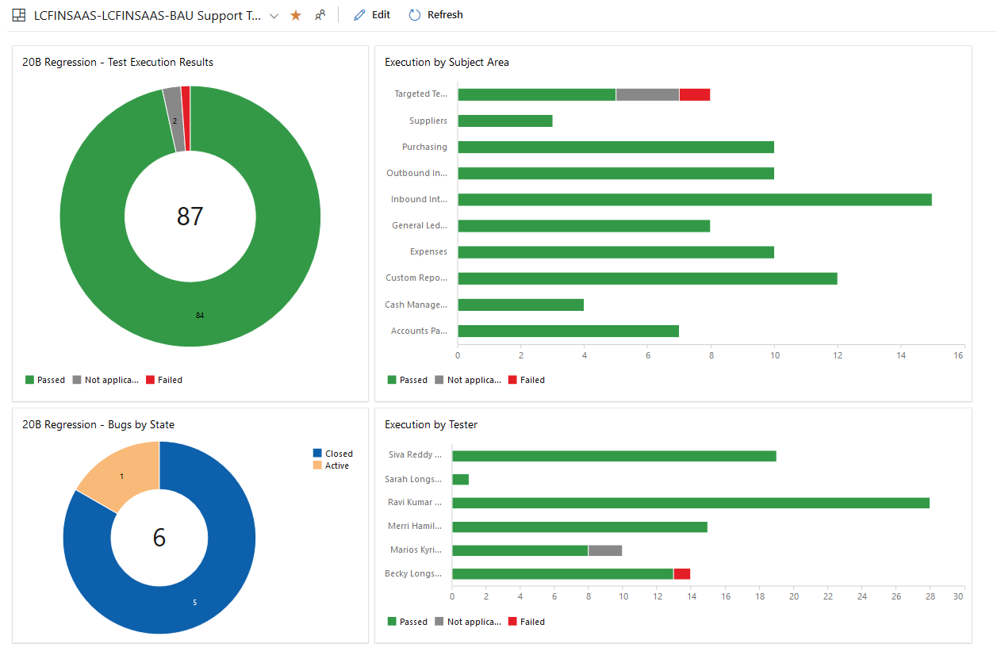

## Tests not executed

|  |  |  |  |  |
| --- | --- | --- | --- | --- |
| **ID** | **Title** | **Module / Area** | **Status** | **Comment** |
| 245355 | 20B.20 - Opt In - Add New Approved Requisitions to Existing Open Purchase Orders | Targeted Testing | N/A | Functionality not deemed useful to SRLC |
| 246187 | 20B.60 - Highlight Configuration Elements That Aren't Optimized | Targeted Testing | N/A | No requirement to change tax for Phase1 entities to verify that this is working and so not required to be tested before 20B is applied to production. Will be validated as part of Phase2 SIT activities. |

## Tools and processes

The testing window lasted two weeks as prescribed by Oracle’s quarterly patching process. Testing was performed by members of Version 1, supported by Life Capital and managed via Azure Dev Ops. Any failed tests were linked to associated defects, which were managed by Version 1. Test evidence was captured by testers during test execution and stored in Dev Ops with the test itself.

## Environment set up and testing approach

As discussed and agreed at the planning stage the bulk of the functional and integration testing was carried out in the environments below (last refresh from PROD date 01/01/2020).

|  |  |  |  |
| --- | --- | --- | --- |
| **Env Name** | **Config Requirements** | **Start** | **End** |
| TEST | Clone of PROD as at 01/01/2020 | 04/05/2020 | 15/05/2020 |
| OICTEST | Connected LC environment | 04/05/2020 | 15/05/2020 |

The below exceptions were agreed:

* Loading of bank statements - Marios tested in SIT (DEV4) environment and loaded bank statements using a different method into TEST to enable V1 to complete the other Cash management regression tests.
* Payment file transmission - Marios tested in SIT (DEV4) environment. The payment regression tests in TEST were run until the payment file was generated. This was then downloaded and viewed as an xml file to validate.

## Test execution entry criteria

The following entry criteria was agreed.

|  |  |  |
| --- | --- | --- |
| **Criteria** | **Met / not met** | **Mitigation factors (if not met)** |
| Recent environment refresh complete | Not met | Last refresh date of TEST was 01/01/20 however a review of in-flight changes was carried out to ensure regression testing was valid. |
| Functional test plan, processes, tools and test suite in place | Met |  |
| Test resources agreed (V1 and Life Capital supporting resource) | Met |  |
| Test environment set up complete | Met |  |

## Test execution exit criteria

The following exit criteria was agreed.

|  |  |  |
| --- | --- | --- |
| **Criteria** | **Met / not met** | **Mitigation factors (if not met)** |
| All in scope functional regression tests have been run or exceptions agreed. | Met |  |
| Evidence captured and stored in Azure Dev Ops as appropriate | Met |  |
| All bugs up to date, with workarounds agreed for any open defects | Met |  |
| Test Completion Report Approval | WIP |  |

## Evidence of Regression Test Completion

**Functional testing**

All functional testing across the agreed scope of modules was tracked in Azure Dev Ops via summary dashboards. Test evidence can be found in Azure Dev Ops.

# Defects

## 

This section summarises the defects identified during the course of the test phase and for any outstanding defects agreed action plan to resolve and/or workarounds.

## Failed tests

1 test remains failed at the end of the testing window for which an Oracle SR is logged and being managed – the issue impacts functionality not currently used by SRLC.

|  |  |  |  |  |
| --- | --- | --- | --- | --- |
| **ID** | **Title** | **Module / Area** | **Status** | **Comment** |
| 245834 | 20B.50 - Retain Receipt Method and Payment Instrument on Complete Transactions | Targeted Testing | Failed | Open SR with Oracle |

## Defect Status Summary

A total of 6 defects were identified during the test window – see below for summary details 1 single defect remains open, as describe above the issue impacts functionality not currently used by SRLC.

|  |  |  |  |
| --- | --- | --- | --- |
| **Azure DevOps Bug Number** | **Title** | **Defect Status** | **Resolution** |
| 242803 | AP.090 - Verify AP Accounting Entries Failed | Closed | Missing FX Rates added |
| 242879 | Expenses Email Approval Notifications are not being processed | Closed | Oracle SR bounce |
| 242897 | Email Approval Notifications for Requisitions not received | Closed | Oracle SR bounce |
| 244097 | Own Journal is approved | Closed | Config re-applied to prevent self-approval. This will be manually applied to PROD after 20B is released |
| 244392 | Financial Tax Register - Report output is not as expected. | Closed | Custom report layout was missing from TEST environment (unrelated to 20B). |
| 245971 | No option to enter Receipt Method and Payment Instrument before completing the transaction. | Active | Open SR to clarify how functionality behaves |

# 5.Communications

It was agreed with Life Capital that they would update any documentation necessary to reflect the changes introduced with the release.

# 6.Lessons Learned

The only lesson learned identified over and above those already identified and actioned previously was the preference to have a recent P2T clone (PROD to TEST) completed on the TEST environment prior to starting regression testing.

## Issues and Recommended Actions

|  |  |  |
| --- | --- | --- |
| **Issue** | **Proposed Action** | **Owner** |
| TEST environment should ideally have been refreshed more recently from PROD. | Review and request PT2 clone closer to the start of quarterly release being applied. | Marios Kyriakides |





[**www.version1.com**](http://www.version1.com)

*`*